**Name: Shaifa Shala**

**USN: 4AL17CS084**

**1- Consider the following relations:**  
**Student (snum: integer, sname: string, major: string, level: string,age: integer)**  
**Class (name: string, meets at: string, room: string, d: integer)**  
**Enrolled (snum: integer, cname: string)**  
**Faculty (fid: integer, fname: string, deptid: integer)**  
**The meaning of these relations is straightforward; for example,**  
**Enrolled has one record per student-class pair such that the student**  
**is enrolled in the class. Level is a two character code with 4 different values (example: Junior: JR etc)**

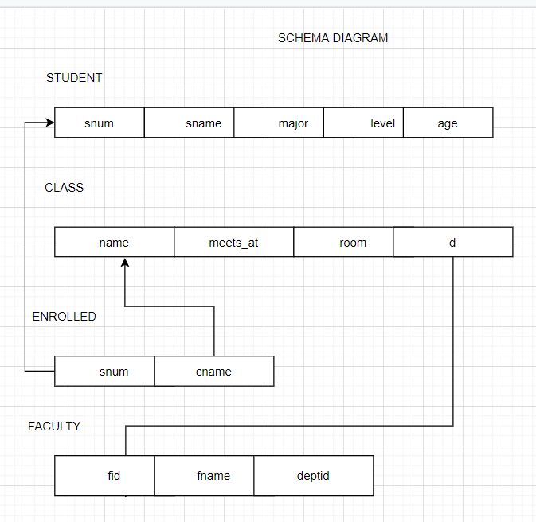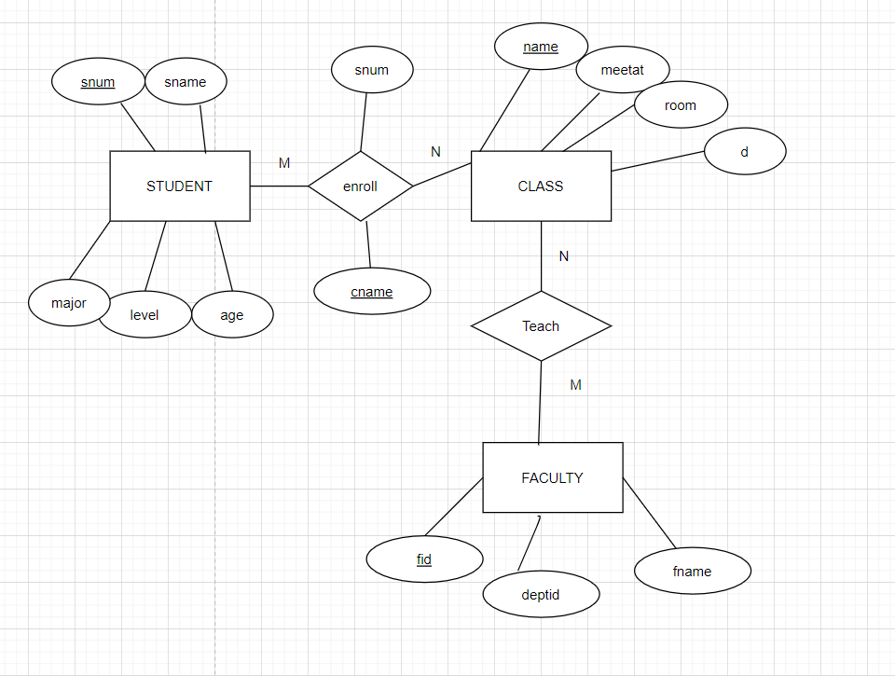

**2- Consider the following database for a banking enterprise**  
**BRANCH(branch-name:string,branch-city:string,assets:real)**  
**ACCOUNT(accno:int,branch-name:string,balance:real)**  
**DEPOSITOR(customer-name:string,accno:int)**  
**CUSTOMER(customer-name:string,customer-street:string,city:string)**  
**LOAN(loan-number:int,branch-name:string,loan-number-int)**  
**BORROWER(customer-name:string,customer-street:string,city:string)**

